Minesweeper
Minesweeper is a game.
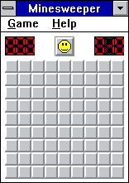Minesweeper
The goal of Minesweeper is to uncover all the squares on a grid that do not contain mines without being “blown up” by clicking on a square with a mine underneath. The location of most mines is discovered through a logical process, but some require guessing, usually with a 50-50 chance of being correct. Clicking on the game board will reveal what is hidden underneath the chosen square or squares (a large number of blank squares [bordering 0 mines] may be revealed in one go if they are adjacent to each other). Some squares are blank while others contain numbers (from 1 to 8), with each number being the number of mines adjacent to the uncovered square.
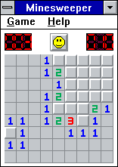Opened board
To help the player avoid hitting a mine, the location of a suspected mine can be marked by flagging it with the right mouse button; however, if a player is unsure if a square is safe or not, they can tag it with a question mark (?). The game is won once all blank or numbered squares have been uncovered by the player without hitting a mine; any remaining mines not identified by flags are automatically flagged by the computer. However, in the event that a game is lost and the player had mistakenly flagged a safe square, that square will either appear with a red X, or else a red X covering the mine (both denoting the square as safe).
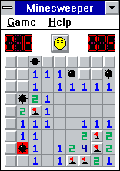Fail

Starting game
To start new game select New item from Game menu, press F2 or click Smile button.

Game mode
You can change game mode by selecting item Beginner, Intermediate or Expert from Game menu. Also you can define custom game mode by selection Custom item.
Beginner
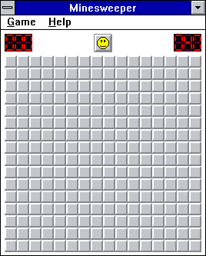Intermediate
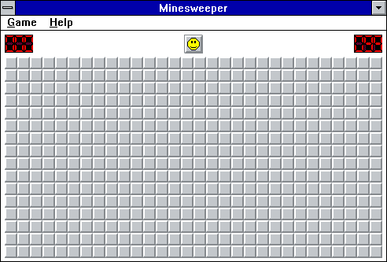Expert

Help marks
Right mouse click allow to set '?' marks. You can disable or enable such mode selecting Mark (?) item from Game menu.

Best times
To show best time results of previous games select Best Times item from Game menu.
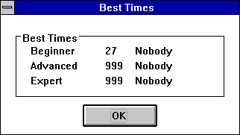Best times

Download
You can download source code and binaries from GitHub. Minesweeper comes under LGPL-2.1 license.

Notes
Text partially based on https://en.wikipedia.org/wiki/Microsoft_Minesweeper
Win16 Applications
Calculator Calendar CARDFILE CHARMAP Clipboard Viewer Clock Control Panel DRWATSON EXPAND FASTOPEN MPLAYER MSD Notepad PACKAGER PBRUSH PIF Editor printman Program Manager regedit setup SOL soundrec System Configuration Editor Task Manager WINFILE WINHELP Minesweeper winsheld Windows Version write

