OS/2 Installable file systems
Cover page
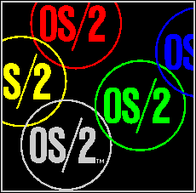 | Installable File Systems  For OS/2 Version 2.0  OS/2 File Systems Department  PSPC Boca Raton, Florida  Translated to IPF by Andre Asselin  Version 0.1  July 1993


Table of Contents
- Disclaimer
- Changes
- Installable File System Mechanism
- FS Service Routines
- FS Helper Functions
- Remote IPL/Bootable IFS
- mini-FSD Entry Points
- mini-FSD Helper Routines

